**Assignment – 1**

* **Install Power BI Desktop and share the final screenshot of the report view page which appears when power desktop starts.**

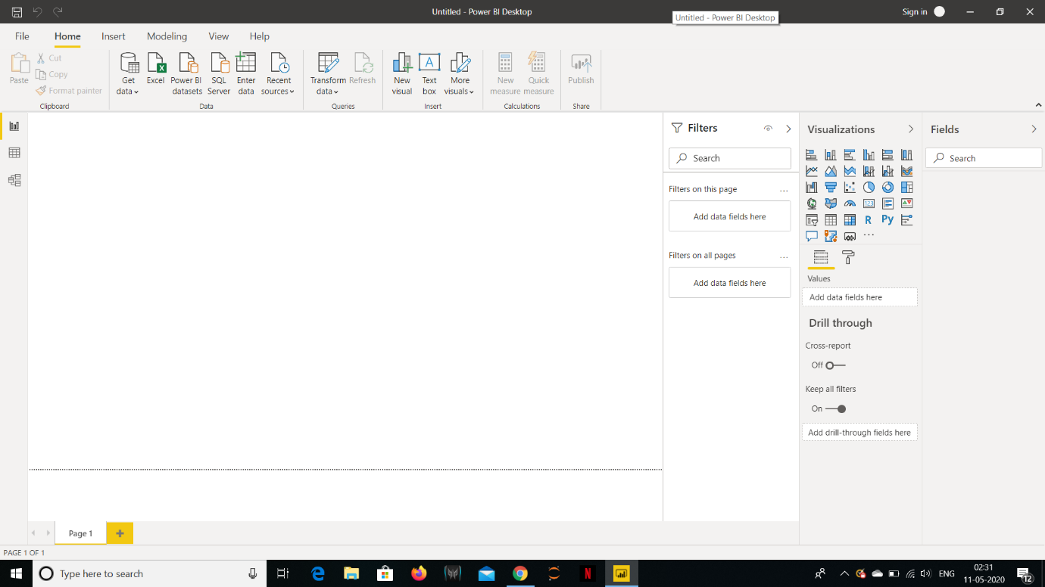

* **Prepare a document and with the following screenshot**

*− Report View*

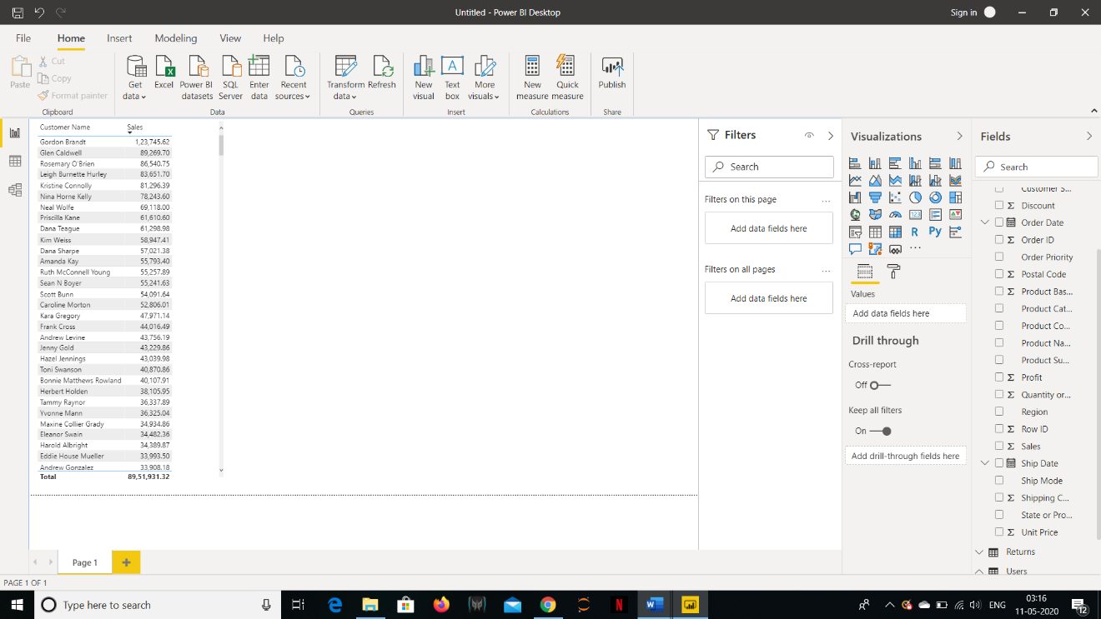

* + *Data View*

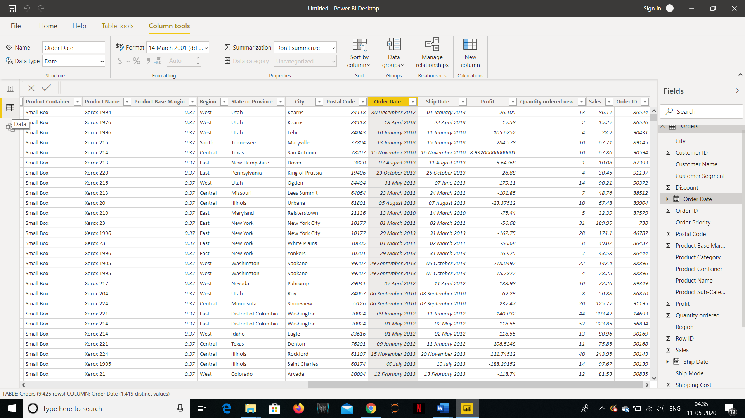

* + *Model View*

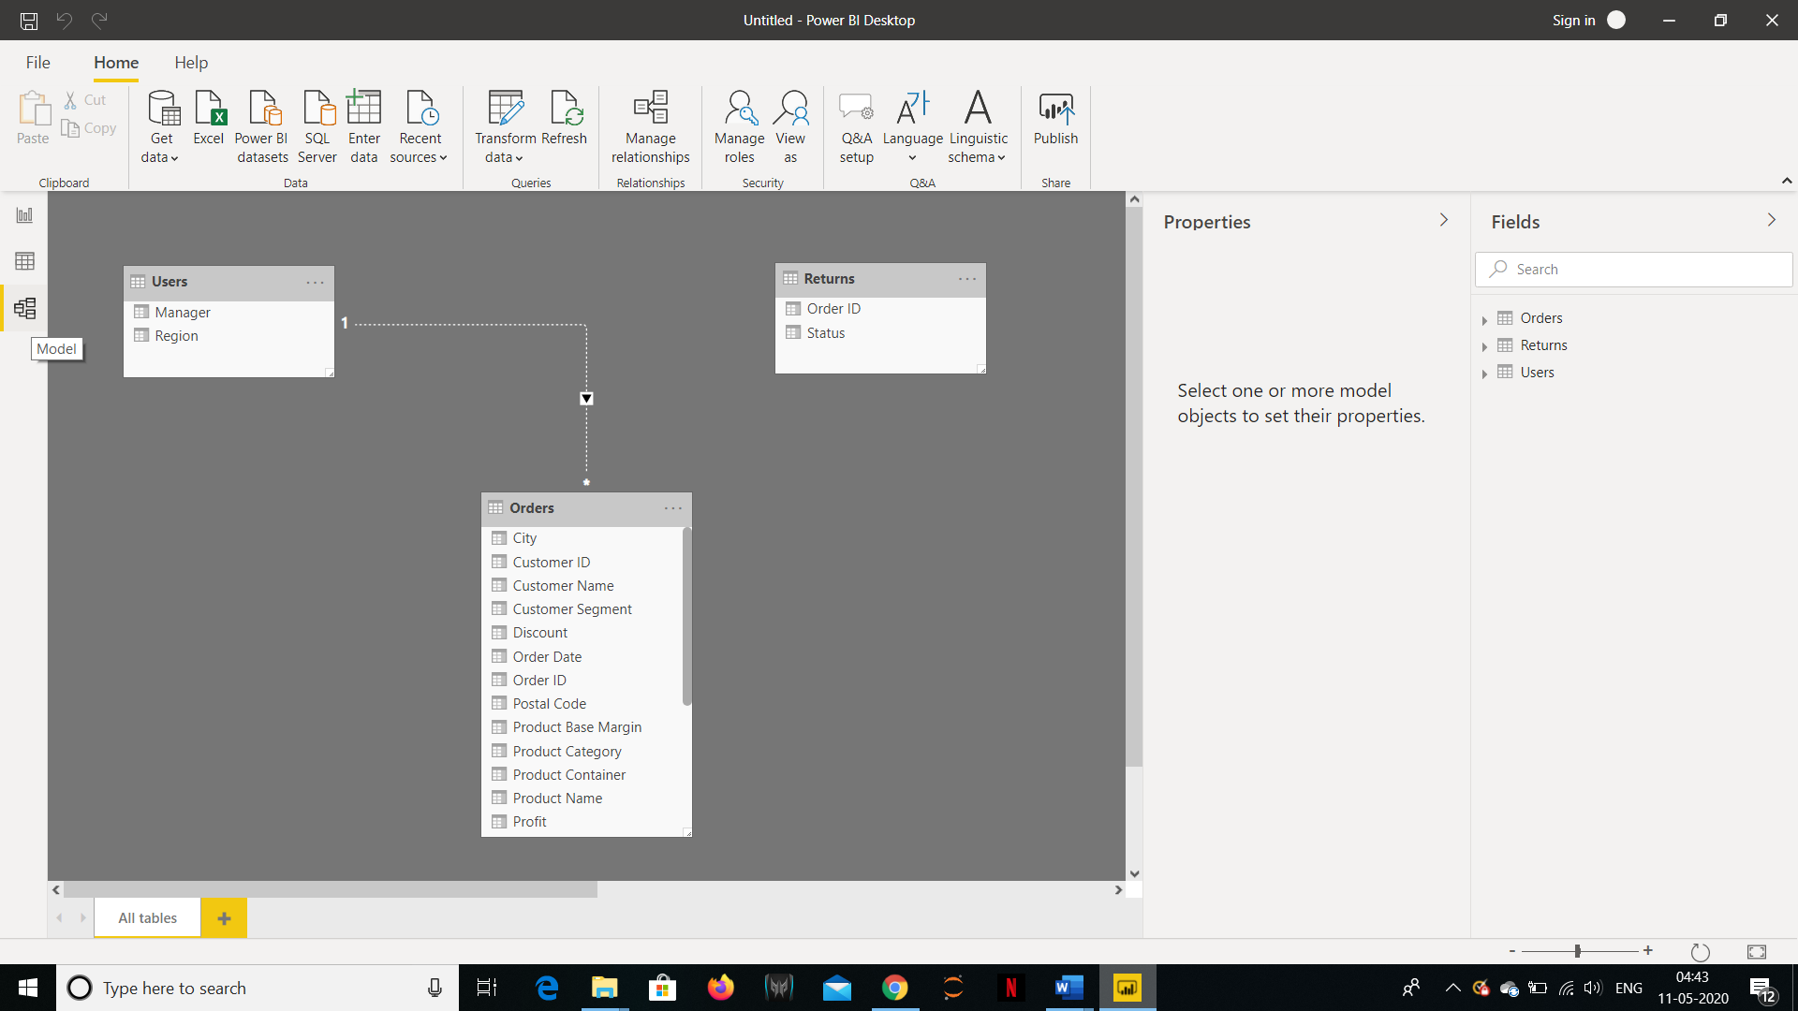

* + *Power Query Editor*

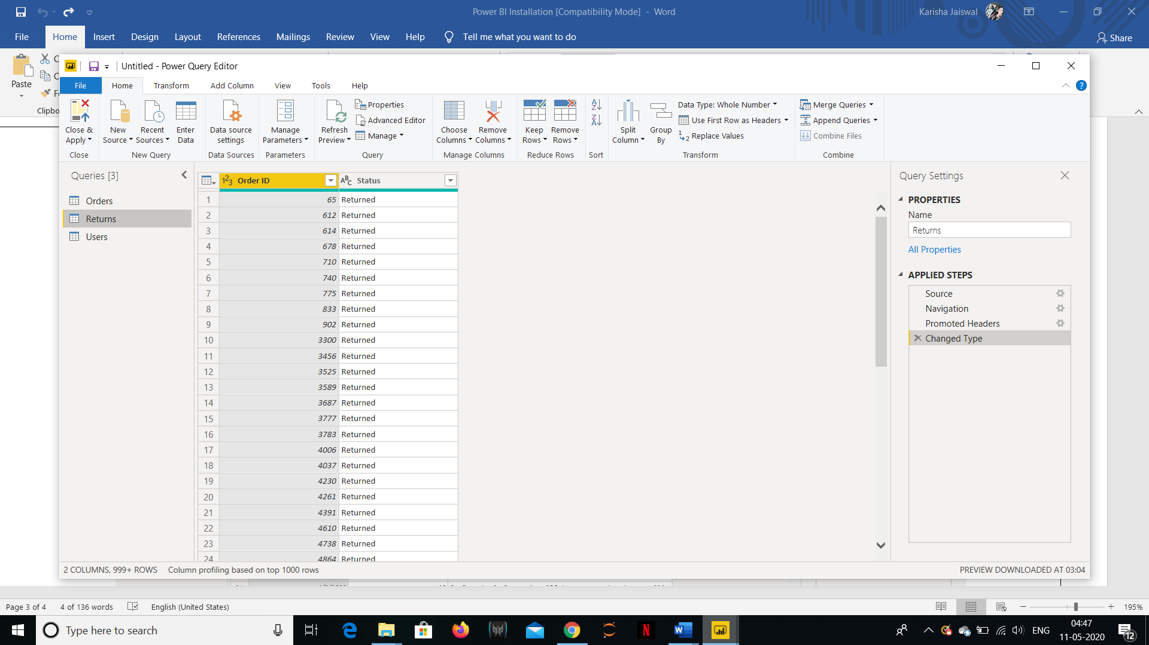

* + *Advanced Editor*

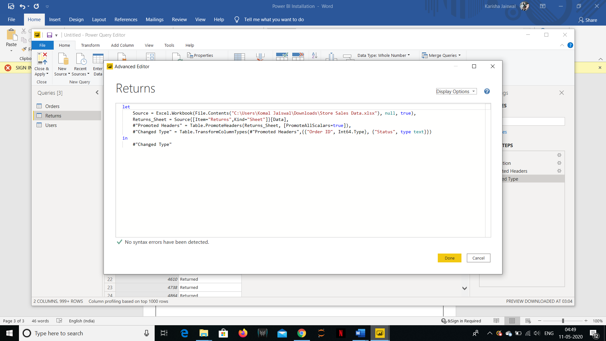

* **Prepare a document with details of the following along with their price**

|  |  |  |
| --- | --- | --- |
| **Product** | **Additional Features** | **Price** |
| Power BI Desktop | 1. Power BI is a cloud-based business analytics service that gives you a single view of your most critical business data. 2. Monitor the health of your business using a live dashboard, create rich interactive reports with Power BI Desktop. | Free |
| Power BI Pro | 1. Self-service and modern BI in the cloud. 2. Collaboration, publishing, sharing, and ad-hoc analysis. 3. Fully managed by Microsoft. | $9.99  Monthly price per user |
| Power BI Premium | 1. Enterprise BI, big data analytics, cloud and on-premises reporting. 2. Advanced administration and deployment controls. 3. Dedicated cloud compute and storage resources. 4. Allows any user to consume Power BI content. | $4,995  Monthly price plus dedicated cloud compute and storage resource with annual subscription |